Evan Till

Website Audit

**Client Name:** Calvin N Hobbs

**Website Type:** Restaurant

**Client Wishlist:** features that are equal or better than competitor’s

1. Sign in/sign up… Save preferences and meals previously ordered
2. Guest login for those that do not want to login/signup
3. Search bar
4. Reservations page
5. Address input for delivery services
6. Variety of menus… Current deals, Lunch, dinner, dessert, allergy tolerant and beverage menus.
7. Cart
8. Checkout
9. Track order… Track delivery
10. Contact page
11. About page
12. FAQ pages

**Use Cases:**

1. **Sign-in / Signup**
   * Save preferences of address for delivery, save previously ordered meals, delivery instructions and payment methods
2. **Reservation**
   * Select date and time for party to dine in restaurant
3. **Browse Menu**

* Allow customers to view menu before coming to establishment and ingredients in case of allergy concerns
* View and sort the different menus for order in person and online/ delivery purposes

1. **Add to cart**
   * Add different items from the menus to cart, ready to be paid for and sent for delivery
2. **Place order**
   * Double check cart
   * Add instructions for food (add/remove/on the side)
   * Delivery/ Pick-up
3. **Payment processing page**
   * Add external Promo Code (additional discounts)
   * Add card details for payment before the delivery of items (credit card, gift card, Visa options)
   * Add delivery instructions (hand off, Leave at door)
4. **Address management**
   * Double check address
   * Enter address for those that choose not to sign-in / signup
5. **Track Order**
   * Track the progress of food preparation and delivery progress
   * Estimate time before food is delivered
6. **Review Services**
   * Rate and review orders or services
   * Provides opportunity to continually improve day to day
7. **Customer service**
   * Allow customers to have live chat with employees
   * Access FAQ pages
   * Resolve issues with recent orders
8. **Location**

**Minimum use:**

1. User goes to website.
2. User sees what we have to offer. (e.g. Menu, Delivery services, Reservations, FAQ, Contact info)
3. User decides whether they wish to use our services or not.

**Maximum use:**

1. User goes to website.
2. User navigates to preferred page. (e.g. Delivery services, Reservations, Contact info)
3. User decides…
   * Delivery. Selects Items off menu. Inputs address info and method of payment. Orders food
   * Reservation. User selects date and time to reserve table. User hits confirm and has a table reserved for said date and time.
   * Contact info. User goes to contact info. Selects phone number or email. User makes request for information, or complaint. Customer receives answers to questions able to be answered. Users’ complaint is heard and rectified to the best of employee’s ability.
4. User receives desired items ordered via website or in person.
5. User enjoys food and, or beverages.
6. User has the best experience possible and receives delicious food

**Similar Websites:**

1. Olive Graden <https://www.olivegarden.com/home>
2. Canadian Brewhouse <https://thecanadianbrewhouse.com>
3. Brewster <https://brewsters.ca>

**How users interact with *Olive Graden*:**

1. User arrives at main page, and navigates to desired operation.

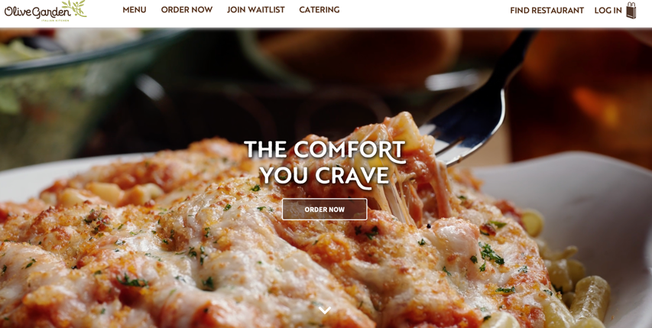

1. User views the menu, adds desired items to cart and orders food.

1. User inputs address and payment info.

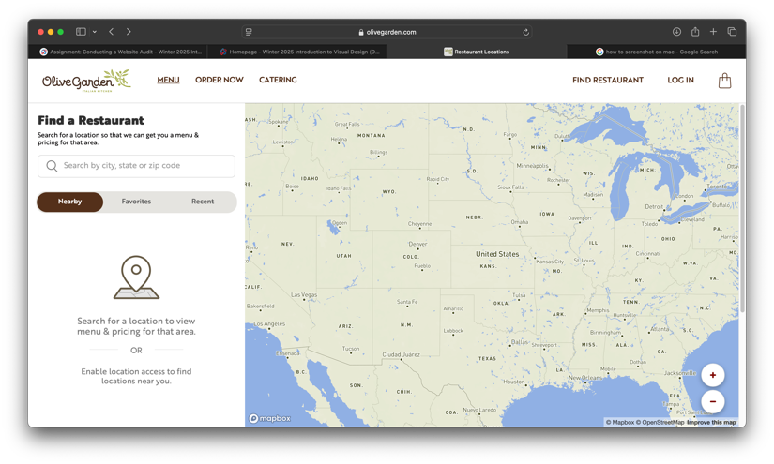

1. User gets order and enjoys food.
2. User Reserves table. Joins waitlist for table reserved.

1. Should the user have questions they go to “*Contact us”* page

|  |  |  |
| --- | --- | --- |
| **Overlaps/Gaps:** | **Overlaps:** | **Gaps:** |
| **Our Website** | * Account Creation * View Menu * Address Input * Reservations * Customer service page * Order Page * Payment Management * Track Order * Cart/Order review * Review Services * Gift cards * Location * About Us | * Nutrition Facts * Waitlist |
| **Olive Gardens website** | * Account Creation * Menu * Address input * Customer Services * Order page * Payment Management * Cart/order review * Track order * Location * About Us | * Catering * Reservations |
| **The Canadian Brewhouse Website** | * View Menu * Order Page * Reservations * Customer Services * Payment Management * Track Order * Cart/Order review * Gift Cards * Location * About Us | * Account creation * Social media links * Nutritional Facts * Catering * What’s happening * App |
| **Brewsters Brewing Website** | * Menu * Location * Customer Services * Order * Payment Management * Address Input * Location * About Us | * Brewing * Events * Log in/ Sign up * Social Media links * Reservations |

**Common Challenges**

1. **User struggles with Log in / Sign up:**
   * User may already have a forgotten account, email, Password and or an invalid email. Allow customers to use a recovery method of their choosing via another email or phone number.
2. **User struggles with order delivery:**
   * User may have input an invalid address or is outside of designated delivery range.
   * User’s payment method did not go through. Inform the user of failed payment.
3. **User struggles with entering payment method:**
   * Users card is expired, CCV is incorrect, or card number is incorrect.
4. **User struggles with making a reservation:**
   * User has selected a date and time that has already been filled.
   * User selected a date and time in the past.